**CHAPTER 3- Lambda Function**

The Lambda function is used to integrate many AWS services. Here we choose the Lambda for two major reasons:

* The first is to use the Department predicted by the bot to retrieve data from the Doctor Info DynamoDB table.
* Second, it is utilized to control the conversation's pace and handle errors.

Now for the intents:

**Greetings:** The lambda function is used for purpose to show the response card with the names of all the doctors with respect to the department selected by the bot.

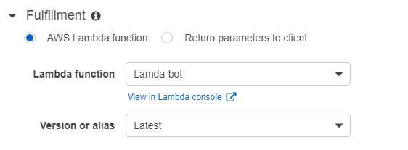

**BookAnAppointment:** Lambda function is used here to fill the slots using **Elicit slot** type meaning Informs Amazon Lex that the user is expected to provide a slot value in the response.Hence the lambda function is used her in the Dialog Hook. Hence in this intent lambda function has an integral function of controlling the flow of the dialogue and also for error handling.

* The function used to control the flow of the dialog is *bookappointment()*.
* The in-built function client_lex.get_session used in the function bookappointment() is used to get the information from the previous intent Greetings.

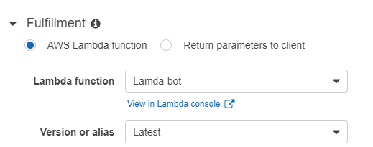

Libraries used in Lambda function are *boto3*,*json* and *aws-cli* .

* ***boto3*** : Boto is the Amazon Web Services (AWS) SDK for Python. It enables Python developers to create, configure, and manage AWS services.
* ***json*** : Json is used here as all the data transmission in aws is done in json format.